Karim Gideon

Jazz Musician, Trumpet, Flugelhorn

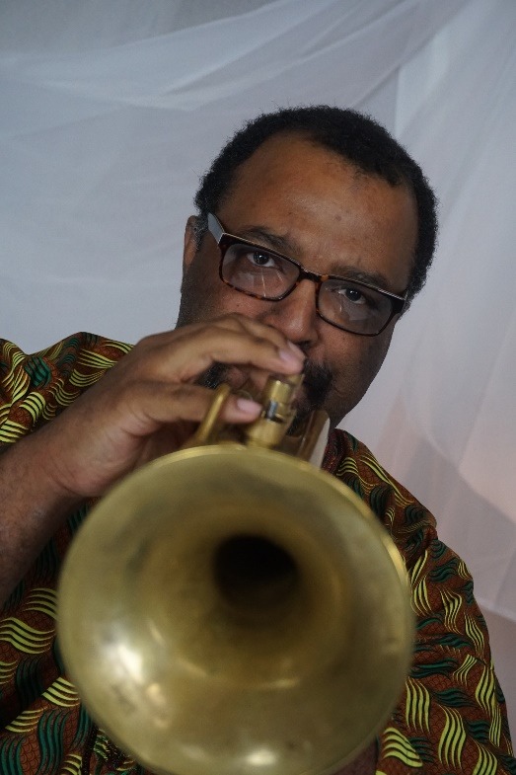
Karim Gideon musical journey began in middle school playing trumpet at the age of 10. By the time he reached high school, Karim developed a growing interest in jazz music that caught the attention of Dr. Teddy Harris Jr. who was an accomplished musician, arranger, and educator.

Under his tutelage, he was encouraged to seek out noted musicians like Marcus Belgrave and Harold McKinney to further his development, and the later would Provide the ultimate training ground at his weekly jazz workshop at the Serengeti ballroom.

Upon graduation, Karim would enlist the United States Navy. While in the navy, he was stationed in Japan near Tokyo where He was working the jazz scene continuing his development. His military career took him from Tokyo, Dubai, Norfolk, and Afghanistan.

After receiving an honorable discharge from active duty, Karim pursue a degree in music at Wayne State University.

Karim has performed with Randy Weston, Joshua Redman, Sean Jones, Danilo Perez, Scott Gwinnell, Omar Sosa, Glen Hall, Bernie Koenig.

He is currently a member of In the Tradition jazz Ensemble under the Direction of Olujimi Tafatooa, and can be heard on their current album "Ancestral Alliances."

